UNIT-III

**LINEAR WIRE ANTENNAS & TRAVELLING WAVE ANTENNAS**

**Antenna array :**

Antenna array is one of the common method of combining the radiations from a group or array of similar antennas in which the phenomena of wave interference is involved. The total field(not power) PRODUCED BY an antenna array system at a great distance from it, is the vector sum of the fields produced by the individual antenna of the fields produced by the components depend on the relative distance of the individual antenna of the antenna array and, in turn depends on the direction.

An antenna array is said to be linear, if the individual antennas of the array are equally spaced along a straight line. A individual antenna array system is also turned as ' ELEMENT'. Thus linear antenna array is the system of equally spaced elements.

A uniform linear array is one , in which the elements are fed with a current of equal magnitude with uniform progressive phase shift along the line. The term “ phase” in an antenna array and ordinary circuit has same meaning I.e, two currents in two elements are said to be in phase if they reach their maximum values, flowing in the same direction at the same instant.

The antennas may put in various configurations eg. In straight line, circle, triangles, rectangles etc., and hence there are large number of possible configurations.

**Various forms of antenna arrays:**

**A) Broad side array:**

According to the standard definition, “An arrangement in which the principal direction of radiation is perpendicular to the array axis and also to the plane containing the array element” is termed as the **broad side array**. Hence, the radiation pattern of the antenna is perpendicular to the axis on which the array exists.

The following diagram shows the broad side array, in front view and side view, respectively.

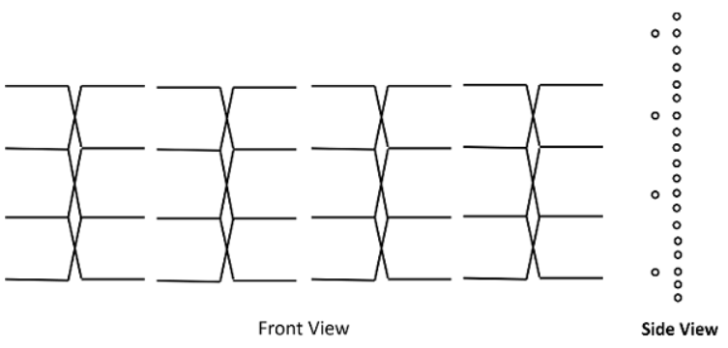

The broad side array is strongly directional at right angles to the plane of the array. However, the radiation in the plane will be very less because of the cancellation in the direction joining the center.

The figure of broad side array with λ/4 spacing is shown below.

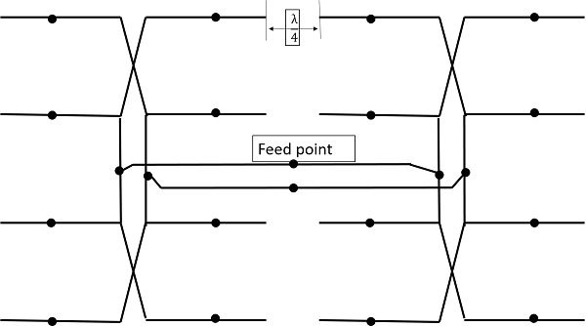

Typical antenna lengths in the broad side array are from 2 to 10 wavelengths. Typical spacing's are λ/2 or λ. The feed points of the dipoles are joined as shown in the figure.

**Radiation Pattern**

The radiation pattern of this antenna is bi-directional and right angles to the plane. The beam is very narrow with high gain.

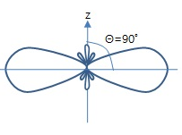

The above figure shows the radiation pattern of the broad side array. The beam is a bit wider and minor lobes are much reduced in this.

# B) End-fire Array:

The physical arrangement of **end-fire array** is same as that of the broad side array. The magnitude of currents in each element is same, but there is a phase difference between these currents. This induction of energy differs in each element, which can be understood by the following diagram.

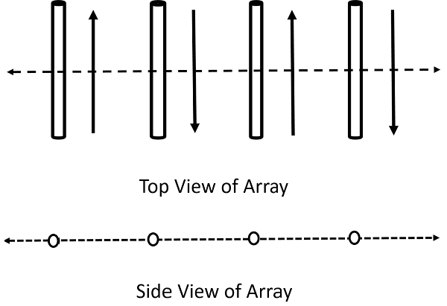

The above figure shows the end-fire array in top and side views respectively.

There is no radiation in the right angles to the plane of the array because of cancellation. The first and third elements are fed out of phase and therefore cancel each other’s radiation. Similarly, second and fourth are fed out of phase, to get cancelled.

The usual dipole spacing will be λ/4 or 3λ/4. This arrangement not only helps to avoid the radiation perpendicular to the antenna plane, but also helps the radiated energy get diverted to the direction of radiation of the whole array. Hence, the minor lobes are avoided and the directivity is increased. The beam becomes narrower with the increased elements.

**Radiation Pattern**

The Radiation pattern of end-fire array is **uni-directional**. A major lobe occurs at one end, where maximum radiation is present, while the minor lobes represent the losses.

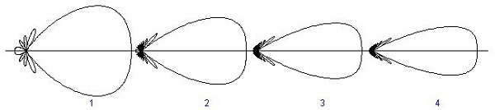

The figure explains the radiation pattern of an end-fire array. Figure 1 is the radiation pattern for a single array, while figures 2, 3, and 4 represent the radiation pattern for multiple arrays.

C) **Binomial Array:**

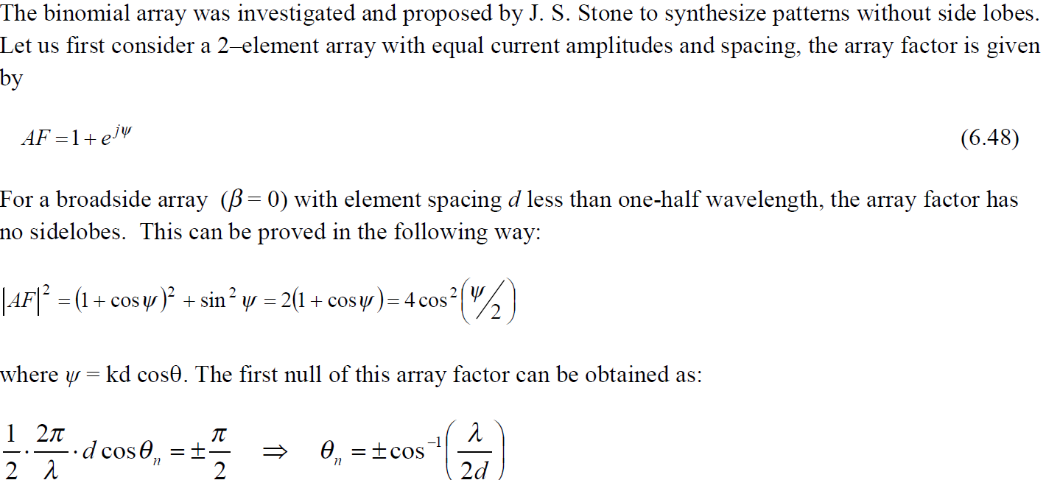

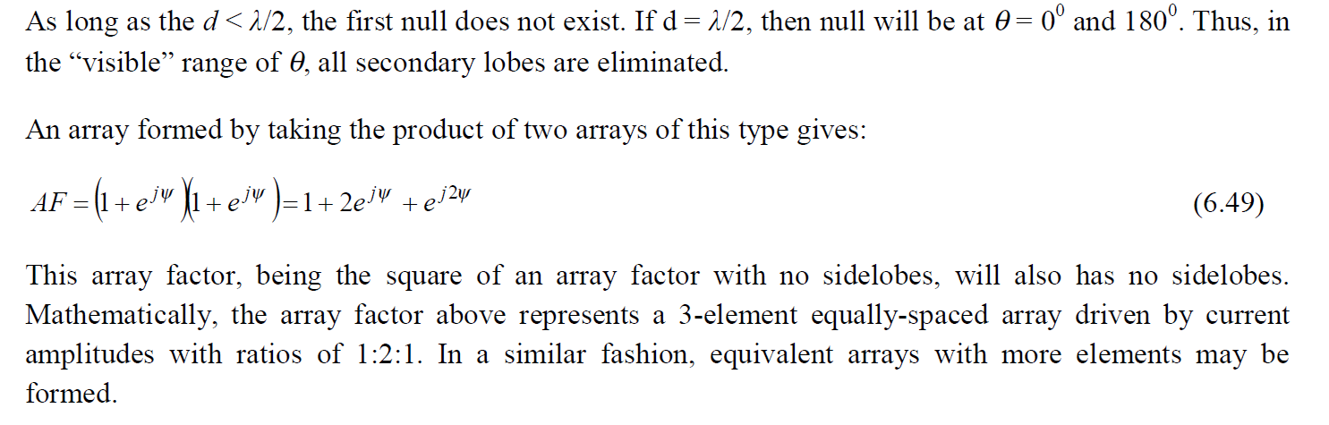

**End-fire Array Vs Broad Side Array:**

We have studied both the arrays. Let us try to compare the end-fire and broad side arrays, along with their characteristics.

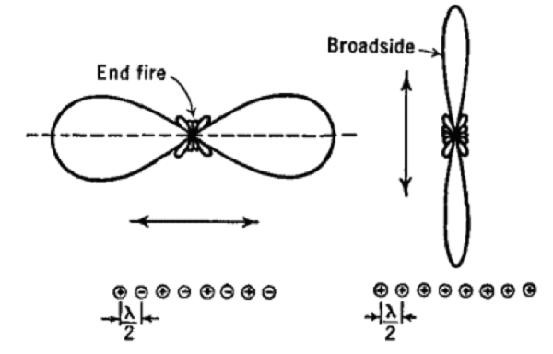

The figure illustrates the radiation pattern of end-fire array and broad side array.

* Both, the end fire array and broad side array, are linear and are resonant, as they consist of resonant elements.
* Due to resonance, both the arrays display narrower beam and high directivity.
* Both of these arrays are used in transmission purposes.
* Neither of them is used for reception, because the necessity of covering a range of frequencies is needed for any kind of reception.

**Array of point Source :**

An antenna array is an assembly of radiating elements. Radiation pattern of a single element is relatively wide, each element provides low values of directivity. However, in many applications we require antennas with very high directive characteristics. The directive characteristics of the antennas can be improved by increasing the electrical size of the antenna. One way to increase the dimension of the antenna without necessarily increasing the size of the individual elements is to form an array of antenna elements. The total field of the array is determined by the vector addition of the fields radiated by the individual elements. The elements of the array need not be identical, but it is often convenient and simpler to design such arrays when the individual elements are considered to be identical. Therefore, here we will consider an array with identical elements. In designing arrays we have several controls such as geometrical configuration of the overall array, distance between the elements, excitation (amplitude and phase) and pattern of individual elements.

**Array of identical elements:**

In this section we establish the basic methodology for analyzing an array of identical elements.

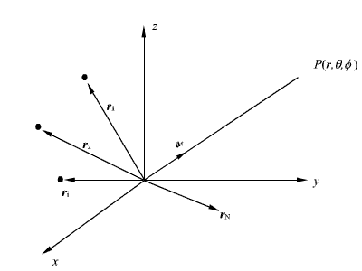

Fig. 7.12: A general N – element array.

As shown in fig 7.12, let us consider an array of N identical elements. The position vector of the *i*th element is given by. The excitation of *i*th element is given  where  and  are respectively the relative amplitudes and phases.

Let the electric field radiated by an element, when placed at the origin and with an unity excitation is given by

……………………..(7.55)

The distance from the *i*th element to the far field point of interest is  for phase variation and  for amplitude variation.

The total electric field at the point *P* is given by

……………………….(7.56)

As can be seen from (7.56), the total radiation field is given by the product of the radiation field of the reference element and the term .

The term ………………………....(7.57) is called the array factor of the antenna array.

The directivity of the array. Thus we find that the radiation pattern of an array is the product of the ……… function of the individual element with the array pattern function. This termed as principle of pattern multiplication.

If we consider isotropic elements then ; hence the radiation pattern of the array depends only on the array factor . Further, it is worth mentioning here that while discussing the properties of array we are neglecting the effect of radiation of one element on the source distribution of the other, i.e., we assume that mutual coupling effect among the elements of the array are neglected. Such effects are included when very accurate characterization of arrays is required.

**Two element array:**

In equation (7.57) we derived the expression for the array factor for an N- element array. To simplify our discussion, let us consider a two-element array. Further, we consider the elements are to be isotropic point sources. The array configuration under consideration is shown in Fig. 7.13.

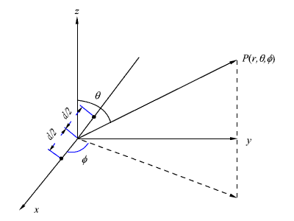

Fig 7.13: Two element array of isotropic point sources.

For this array, from (7.57) the array factor is given by





We now consider some specific cases.

**Case -1:**

Point sources have same amplitude and phase.

For this case we consider 

& 





Let us plot the array pattern on *xy* plane i.e., . Fig 7.14 (a) – Fig 7.14(d) show the nature of variation of the array factor as a function of .

It can be seen that for , the maximum radiation take place in a direction perpendicular to array axis( broad side direction) and no radiation along the axis of the array (endfix) for  the radiation increases along the array axis.

**Case 2:**

Point sources have equal amplitude and opposite phase.

For this case let 

And 



Once again we plot array pattern on the *xy* plane, i.e., . The same is shown in Fig 7.15(a) to Fig 7.15(d).

It can be seen from Fig 7.14(b) and Fig 7.15(b), that for spacing, broadside pattern is obtained for elements having same phase while end side pattern is obtained when the elements are excited in the opposite phase.

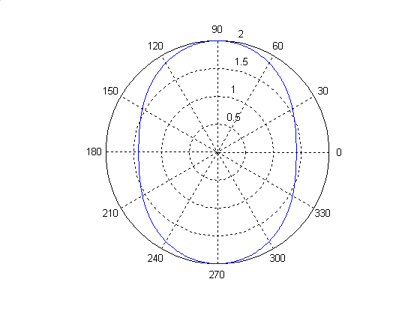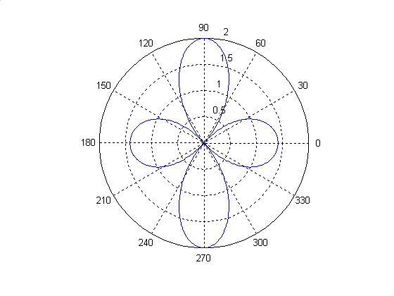

(a)  (b) 

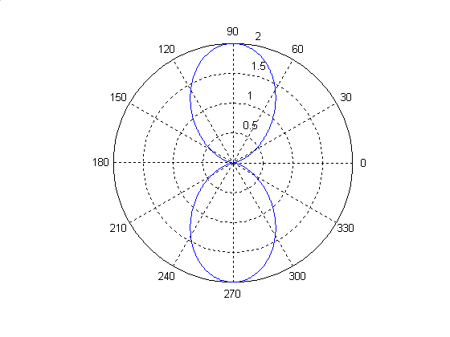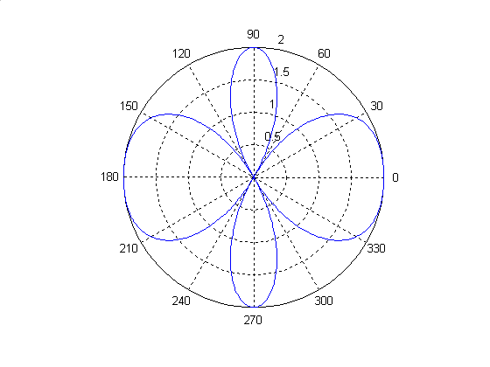

**(c)**  (d) 

Fig 7.14: Plot of  for different values of , the elements excited in the same phase.

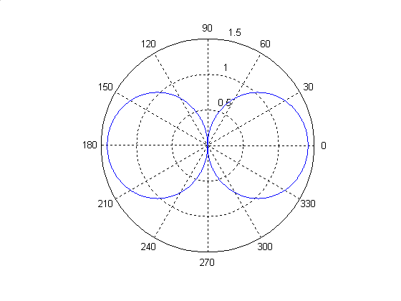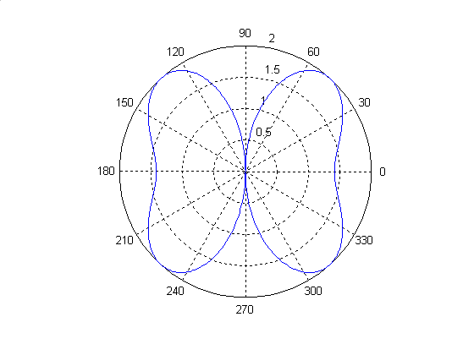

(a) (b) 

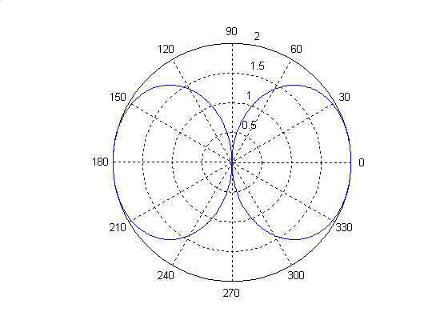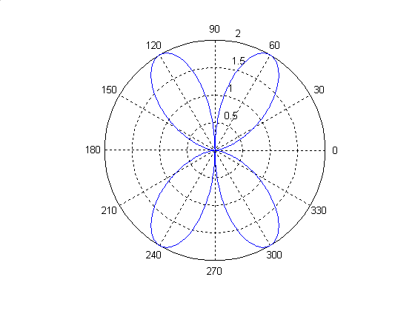

(c) (d) 

Fig 7.15: Plot of  for different values of , the elements excited in different phase.

**Uniform One dimensional array:**

So far, we have considered the behavior of arrays having only two elements. Let us now consider a uniform array having N +1 point sources. Each antenna element is assumed to have same amplitude  and a progressive phase shift of between two elements where‘d’ is the separation between the elements. Thus, with reference to the Fig 7.1b, the ith element has a phase .

Fig7.16: Uniform linear array



Where 

Using the relation

…………………………………….(7.62)

For a G.P. , from (7.61) we can write

……………………..(7.63)

If we define 

and , then from (7.63) we can write array field pattern  to be ………………………..(7.64)

The function defined by equation (7.64) is a periodic function whose peak value occurs at  and when ever  is an integer. The peak value is .

Since  lies in the range , the corresponding range of u,  is the physical space or visible region. The plot of array factors  as a function of u is shown in Fig 7.17.

As we can see from Fig 7.17, along with the major lobe, in the visible space there are several smaller maxima. These smaller maxima corresponds to ride lobes.

**Broad side Case**:

If , i.e., all the elements are in the same phase, then the maximum occurs at u = 0 i.e., .

i.e., . Thus the maximum radiation occurs broad side to array axis. If we consider the pattern in the y plane for which . Then . i.e., maximum radiation is along y-axis.

**End fire Case:**

If  is chosen to be , then the beam maximum is formed along , i.e.,  maximum of the array pattern is formed along the array axis.

**Pattern Multiplication**

**Principle of pattern multiplication** states that the radiation pattern of an array is the product of the pattern of the individual antenna with the array pattern. The array pattern is a function of the location of the antennas in the array and their relative complex excitation amplitudes.

As per theorem that beam pattern of any array is the product of two parts

1. Individual Element Pattern
2. Array factor Pattern

**Individual element pattern** - the pattern of the individual array element.

**Array factor** - a function dependent only on the geometry of the arrayand the excitation (amplitude, phase) of the elements

F1= thepatternfactorofasinglepointsourceradiatorforadipole

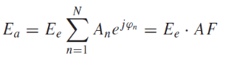F2=thearrayfactorfor the radiatorsforalinearantennaarray:

Ea=F1*F2

**Advantage** of method of multiplication. It helps to sketch the radiation pattern of array antennas rapidly from the simple product of element pattern and array pattern.

**Disadvantage**    The principle is applicable only for arrays containing identical elements.

**Example 1**

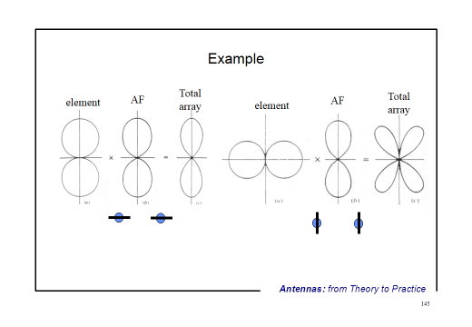

Example 2 : 2 element array equal

Currents in phase spacing λ

Thus the actual pattern is:

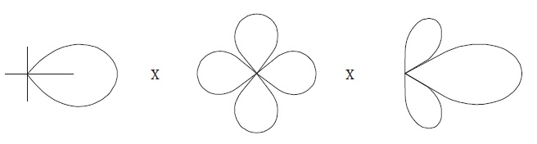

**Travelling Wave Antennas:**

## Types of Long-wire Antennas:

Long wire antennas are divided into two types namely − **Resonant Antennas** and **Non-resonant Antennas**.

### Resonant Antennas

Resonant Antennas are those for which a sharp peak in the radiated power is intercepted by the antenna at certain frequency, to form a standing wave. The radiation pattern of the radiated wave is not matched with the load impedance in this type of antenna.

The resonant antennas are periodic in nature. They are also called as bi-directional travelling wave antennas, as the radiated wave moves in two directions, which means both incident and reflected waves occur here. In these antennas, the length of the antenna and frequency are proportional to each other.

### Non-resonant Antennas

Non-resonant Antennas are those for which resonant frequency does not occur. The wave moves in forward direction and hence do not form a standing wave. The radiation pattern of the radiated wave matches with the load impedance in the non-resonant antennas.

These non-resonant antennas are non-periodic in nature. They are also called as Unidirectional travelling wave antennas, as the radiated wave moves in forward direction only, which means that only incident wave is present. As the frequency increases, the length of the antenna decreases and vice versa. Hence, the frequency and length are inversely proportional to each other.

These long-wire antennas are the basic elements for the construction of V-shaped antennas or the Rhombic antennas

A better version of long-wire antennas is the **V-Antenna**. This antenna is formed by arranging the long wire in a V-shaped pattern. The end wires are called as legs. This antenna is a bi-directional resonant antenna.

### Frequency Range

The frequency range of operation of V-antenna is around **3 to 30 MHz**. This antenna works in high frequency range.

## Construction & Working of V-Antennas

Two long wires are connected in the shape of V to make a **V-antenna**. The two long wires are excited with 180˚ out of phase. As the length of these wires increases, the gain and directivity also increases.

The following figure shows a V-antenna with the transmission line impedance z and the lengh of the wire λ/2, making an angle Φm with the axis, which is called as **apex angle**.

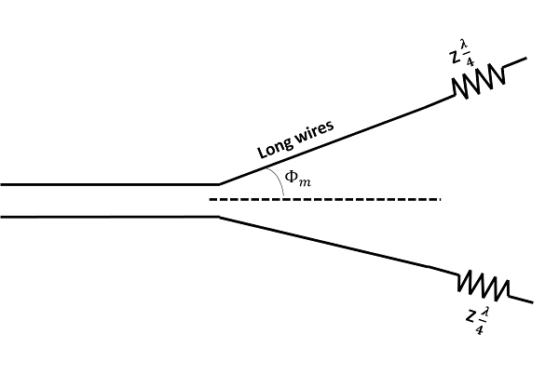

The **gain** achieved by V-antenna is higher than normal single long wire antenna. The gain in this V-formation is **nearly twice** compared to the single long wire antenna, which has a length equal to the legs of V-antenna. If wide range of radiation is to be achieved, the apex angle should have an average value between higher and lower frequencies in terms of the number of λ/2 in each leg.

## Radiation Pattern

The radiation pattern of a V-antenna is **bi-directional**. The radiation obtained on each transmission line is added to obtain the resultant radiation pattern. This is well explained in the following figure −

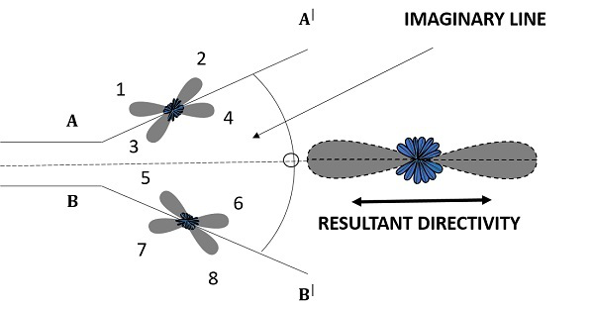

The figure shows the radiation pattern of V-antenna. The two transmission lines forming V-pattern are AA’ and BB’. The patterns of individual transmission lines and the resultant pattern are shown in the figure. The resultant pattern is shown along the axis. This pattern resembles the **broad-side array**.

If another V-antenna is added to this antenna and fed with 90˚ phase difference, then the resultant pattern would be **end-fire**, doubling the power gain. The directivity is further increased by adding the array of V-antennas.

### Advantages

The following are the advantages of V-antenna −

* Construction is simple
* High gain
* Low manufacturing cost

### Disadvantages

The following are the disadvantages of V-antenna −

* Standing waves are formed
* The minor lobes occurred are also strong
* Used only for fixed frequency operations

### Applications

The following are the applications of V-antenna −

* Used for commercial purposes
* Used in radio communications

**RHOMBIC ANTENNA:**

After the V-antenna and inverted V-antenna, another important long wire antenna is the **Rhombic antenna**. It is a combination of two V-antennas.

The **Rhombic Antenna** is an equilateral parallelogram shaped antenna. Generally, it has two opposite acute angles. The tilt angle, θ is approximately equal to 90° minus the angle of major lobe. Rhombic antenna works under the principle of travelling wave radiator. It is arranged in the form of a rhombus or diamond shape and suspended horizontally above the surface of the earth.

### Frequency Range

The frequency range of operation of a Rhombic antenna is around **3MHz to 300MHz**. This antenna works in **HF** and **VHF** ranges.

## Construction of Rhombic Antenna

Rhombic antenna can be regarded as two V-shaped antennas connected end-to-end to form obtuse angles. Due to its simplicity and ease of construction, it has many uses −

* In HF transmission and reception
* Commercial point-to-point communication

The construction of the rhombic antenna is in the form a rhombus, as shown in the figure.

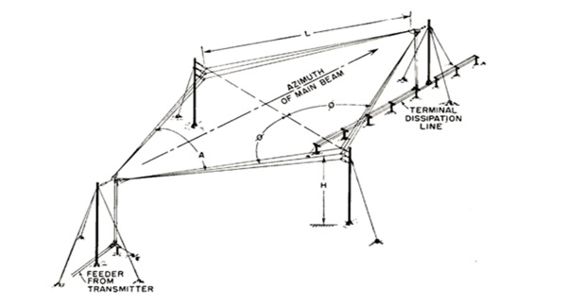

The two sides of rhombus are considered as the conductors of a two-wire transmission line. When this system is properly designed, there is a concentration of radiation along the main axis of radiation. In practice, half of the power is dissipated in the terminating resistance of the antenna. The rest of the power is radiated. The wasted power contributes to the minor lobes.

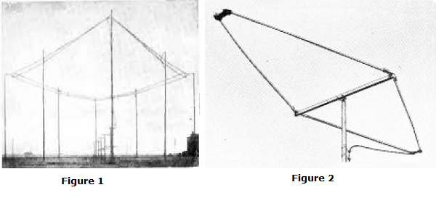

Figure 1 shows the construction of **rhombic antenna** for point-to-point communication in olden days. Figure 2 shows the **rhombic UHF antenna** for TV reception, used these days.

The maximum gain from a rhombic antenna is along the direction of the main axis, which passes through the feed point to terminate in free space. The polarization obtained from a horizontal rhombic antenna is in the plane of rhombus, which is horizontal.

## Radiation Pattern

The radiation pattern of the rhombic antenna is shown in the following figure. The resultant pattern is the cumulative effect of the radiation at all four legs of the antenna. This pattern is **uni-directional**, while it can be made bi-directional by removing the terminating resistance.

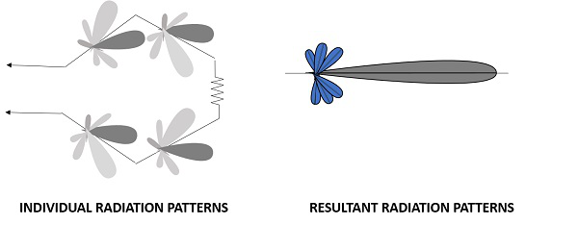

The main disadvantage of rhombic antenna is that the portions of the radiation, which do not combine with the main lobe, result in considerable side lobes having both horizontal and vertical polarization.

### Advantages

The following are the advantages of Rhombic antenna −

* Input impedance and radiation pattern are relatively constant
* Multiple rhombic antennas can be connected
* Simple and effective transmission

### Disadvantages

The following are the disadvantages of Rhombic antenna −

* Wastage of power in terminating resistor
* Requirement of large space
* Redued transmission efficiency

### Applications

The following are the applications of Rhombic antenna −

* Used in HF communications
* Used in Long distance sky wave propagations
* Used in point-to-point communications

**YAGI-UDA ANTENNA** :

**Yagi-Uda antenna** is the most commonly used type of antenna for TV reception over the last few decades. It is the most popular and easy-to-use type of antenna with better performance, which is famous for its high gain and directivity

**Frequency range**

The frequency range in which the Yagi-Uda antennas operate is around **30 MHz to 3GHz** which belong to the **VHF** and **UHF** bands.

## Construction of Yagi-Uda Antenna

A Yagi-Uda antenna was seen on top of almost every house during the past decades. The parasitic elements and the dipole together form this Yagi-Uda antenna.

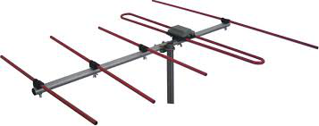

The figure shows a **Yagi-Uda antenna**. It is seen that there are many directors placed to increase the directivity of the antenna. The feeder is the folded dipole. The reflector is the lengthy element, which is at the end of the structure.

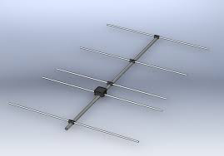

The figure depicts a clear form of the Yagi-Uda antenna. The center rod like structure on which the elements are mounted is called as **boom**. The element to which a thick black head is connected is the **driven element** to which the transmission line is connected internally, through that black stud. The single element present at the back of the driven element is the **reflector**, which reflects all the energy towards the direction of the radiation pattern. The other elements, before the driven element, are the **directors**, which direct the beam towards the desired angle.

### Designing

For this antenna to be designed, the following design specifications should be followed.

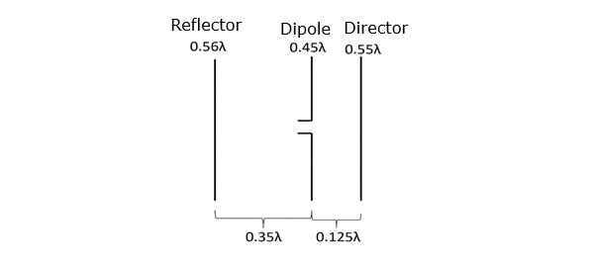

They are −

|  |  |
| --- | --- |
| **ELEMENT** | **SPECIFICATION** |
| Length of the Driven Element | 0.458λ to 0.5λ |
| Length of the Reflector | 0.55λ to 0.58λ |
| Length of the Director 1 | 0.45λ |
| Length of the Director 2 | 0.40λ |
| Length of the Director 3 | 0.35λ |
| Spacing between Directors | 0.2λ |
| Reflector to dipole spacing | 0.35λ |
| Dipole to Director spacing | 0.125λ |

If the specifications given above are followed, one can design an Yagi-Uda antenna.

## Radiation Pattern

The directional pattern of the Yagi-Uda antenna is **highly directive** as shown in the figure given below.

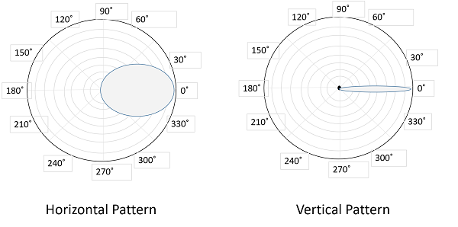

The minor lobes are suppressed and the directivity of the major lobe is increased by the addition of directors to the antenna.

### Advantages

The following are the advantages of Yagi-Uda antennas −

* High gain is achieved.
* High directivity is achieved.
* Ease of handling and maintenance.
* Less amount of power is wasted.
* Broader coverage of frequencies.

### Disadvantages

The following are the disadvantages of Yagi-Uda antennas −

* Prone to noise.
* Prone to atmospheric effects.

### Applications

The following are the applications of Yagi-Uda antennas −

* Mostly used for TV reception.
* Used where a single-frequency application is needed.

**FOLDED DIPOLE:**

A folded dipole is an antenna, with two conductors connected on both sides, and folded to form a cylindrical closed shape, to which feed is given at the center. The length of the dipole is half of the wavelength. Hence, it is called as **half wave folded dipole antenna**.

### Frequency range

The range of frequency in which half wave folded dipole operates is around 3KHz to 300GHz. This is mostly used in television receivers.

## Construction & Working of Half-wave Folded Dipole

This antenna is commonly used with the array type antennas to increase the feed resistance. The most commonly used one is with Yagi-Uda antenna. The following figure shows a half-wave folded dipole antenna.

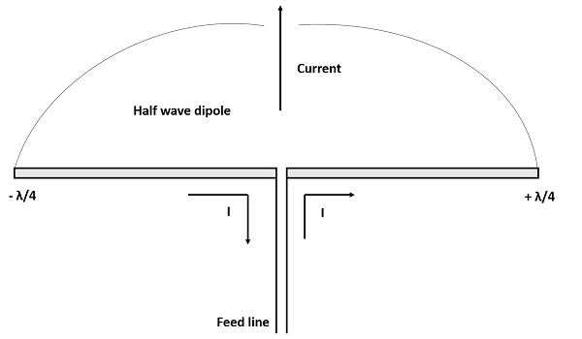

This antenna uses an extra conducting element (a wire or a rod) when compared with previous dipole antenna. This is continued by placing few conducting elements in parallel, with insulation in-between, in array type of antennas.

The following figure explains the working of a half-wave folded dipole antenna, when it is provided with excitation.

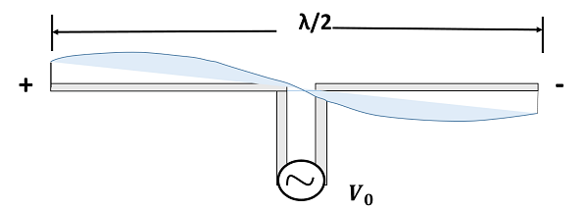

If the diameter of the main conductor and the folded dipole are same, then there will be four folded (two times of squared one) increase in the feed impedance of the antenna. This increase in feed impedance is the main reason for the popular usage of this folded dipole antenna. Due of the twin-lead, the impedance will be around 300Ω.

## Radiation Pattern

The radiation pattern of half-wave folded dipoles is the same as that of the half-wave dipole antennas. The following figure shows the radiation pattern of half-wave folded dipole antenna, which is **Omni-directional** pattern.

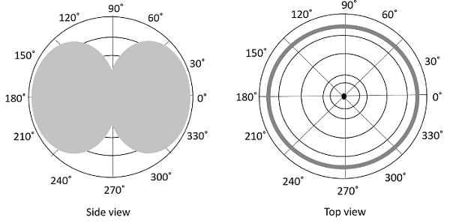

Half-wave folded dipole antennas are used where optimum power transfer is needed and where large impedances are needed.

This folded dipole is the main element in **Yagi-Uda antenna**. The following figure shows a **Yagi-Uda antenna**, which we will study later. The main element used here is this folded dipole, to which the antenna feed is given. This antenna has been used extensively for television reception over the last few decades.

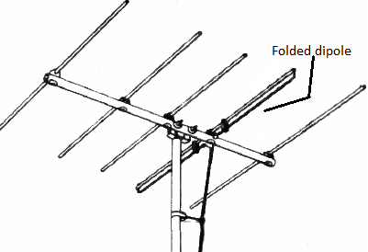

### Advantages

The following are the advantages of half-wave folded dipole antenna −

* Reception of balanced signals.
* Receives a particular signal from a band of frequencies without losing the quality.
* A folded dipole maximizes the signal strength.

### Disadvantages

The following are the disadvantages of half-wave folded dipole antenna −

* Displacement and adjustment of antenna is a hassle.
* Outdoor management can be difficult when antenna size increases.

### Applications

The following are the applications of half-wave folded dipole antenna −

* Mainly used as a feeder element in Yagi antenna, Parabolic antenna, turnstile antenna, log periodic antenna, phased and reflector arrays, etc.
* Generally used in radio receivers.
* Most commonly used in TV receiver antennas.

**Current distribution on a wire antenna:**

